Between Time and Eternity: The Catholic Understanding of Time
Instructor’s Notes
This lecture will give an overview of the Catholic understanding of time. It is grounded in the theology of St. Augustine and draws on the apologetics of C.S. Lewis (who, though not Catholic, illustrates the traditional understanding of time with vivid metaphors).
The second half discusses how time was re-oriented by the Incarnation. This is a good place to make links between the geological timeline from the previous sessions.
You may wish to read Chapter 3, “Time and Beyond Time”, in the last section of C.S. Lewis’ Mere Christianity. and St. Augustine On Genesis and Book XI of The Confessions in preparation for this lecture.
Opening Prayer – the Suscipe of Catherine McAuley
- My God, I am yours for time and eternity.
Teach me to cast myself entirely
into the arms of your loving Providence
with a lively, unlimited confidence in your compassionate, tender pity.
Grant, O most merciful Redeemer,
- That whatever you ordain or permit may be acceptable to me.
Take from my heart all painful anxiety;
let nothing sadden me but sin,
nothing delight me but the hope of coming to the possession of You
my God and my all, in your everlasting kingdom.
Amen.
Catherine McAuley was the founder of the Sister of Mercy. The first line of her most famous prayer is a good frame for this lesson. What does it mean to be God’s “for time and eternity?”
Reflection question: What is time?
Take 3 minutes and write a response to these questions in your guided notes:
- What is time? How would you explain it to a child?

Let’s discuss your responses. If students run into difficulties, you can ask them these additional questions: How do we measure it? What are common saying about time? How would you draw time? Allow time to discuss. This could be in pairs and then in whole group.
St. Augustine of Hippo
- “What then is time? Provided that no one asks me, I know. If I want to explain it to an inquirer, I do not know” (St Augustine, Confessions, p. 242 2008).
What do you make of Augustine answer? Time is difficult to define. [St. Augustine explores the nature of time in On Genesis (389) and in Book XI of The Confessions (397). His ideas have shaped the Catholic understanding of time (including the rest of this lecture), but this is his starting point: I don't know. Augustine continues, “I would rather respond, “I do not know,” concerning what I do not know than say something for which a man inquiring about such profound matters is laughed at, while the one giving a false answer is praised.” There are deep paradoxes and difficulties in understanding time and it is best to proceed cautiously.]

Definition of Time (three attempts)
- Aristotle: time is a measure of change
- Thomas Aquinas: the measure of movement according to an order of anteriority and posteriority (past and future).
- Physics: Time is the continued sequence of existence and events that occurs in an apparently irreversible succession from the past, through the present, and into the future.
Ask students what commonalities they notice in these definitions. What repeated words? What questions do they have about these definitions?
[You could simply give one definition if this feels overwhelming]

Catholic Understanding of Time
- Time is
  - Real, objective, and measurable
  - Not an illusion
  - Linear, not cyclical
  - in motion
    - Unidirectional (one-way)
    - Irreversible
  - Finite, with a beginning and end
  - Created by God
  - Catholic Understanding of Time
[These ideas may seem obvious or unexamined to many American students from a Jewish, Christian, or Muslim background. They are part of our cultural and religious worldviews. It is important to point out that not every religion and culture believes this. For example, Hindus believe that time in cyclical and infinite (as is the human soul). Buddhists also believe in cyclical time, but in a deeper sense, that time is illusion. Reality is marked by change and flux. That only the present moment is truly real. Students may have expressed similar sentiments in their journaling.
Modern physics has largely agreed with the Catholic conception of time as real, objective, and measurable. In fact, Einstein theorized a new fourth dimension called “space-time.” This lesson has focused on connections with geology, but a teacher might wish to extend this lesson with a class on physics. See Stephen Barr, “St. Augustine's Relativistic Theory of Time.” Church Life Journal. University of Notre Dame . February 07, 2020.
Use the line segment and ray to illustrate the concepts of linear, unidirectional, and linear.]
Time is also
  - Subjective:
A phenomenon of human consciousness
  - Socially constructed
[You might bring in students’ idioms about time from the journal: “time flies when you’re having fun,” “killing time,” “a moment that stops time” etc. to illustrate the ways that human beings perceive time subjectively. Different cultures quantify and interact with time in various ways. Compare the way trains run in Germany, on a strict and exact timetable to the loose way things happen in Southern Europe.
St. Augustine writes in The Confessions, that the human mind is able to bring the past into the present through memory. Objectively, time has moved forward from past events, but the human end is able to make it real again. Similarly, human consciousness is able to anticipate the future. ]

  - Time is Created by God
Ask students to consider: what might it mean for time to be created? To be a creation like animals, stars, and human beings? To be designed and built by an architect? This is a place where connections can be made to math and physics.

Two marks of creation
- Time and Space
- Both were created “in the beginning”
- Created ex nihilo (out of nothing)
- Both will end
Our world is defined by time and space. Space provides the dimensionality of the world and includes the physical matter of existence. Time marks and shapes how change progresses. It is difficult for us to imagine what eternity might be like because we can’t really escape these confines—and maybe we shouldn’t want to. Being human means being ‘embodied’ and capable of change. Angels and God are not like us. Language about eternity is difficult. In Scripture and in the Church Fathers we sometimes read about “time before time,” just as we encounter physical descriptions of heaven (as if it were a place like Chicago or Orlando).
Yet time and space had a definite beginning. God created these aspects of our existence ex nihilo (out of nothing) in the beginning. We can see support for this in Genesis 1. Just as the world is finite, so our time and space—at least as we know them. The “eschatological vision” (the picture that Scripture paints of the end times) promises a new heaven and a new earth. We are also promised a resurrection of our bodies. We will not somehow become angels but continue to have a physical existence in some way in the world to come. [This may be too much for students to chew on—you can gauge whether this last version will connect or confuse]

- God’s existence
    - God exists outside of time and space; in eternity
    - Eternity is not the same as infinity.
    - You [God] made all time; you are before all time; and the 'time', if such we may call it, when there was no time was not time at all" (Augustine 263).
Ask: What does this quote mean to you? Is it confusing?
[Eternity might be understood as “the eternal now.” It is dynamic, not static. In the Nicene Creed, for example, we profess that the Son is “eternally begotten” from the Father. This means that there is motion or activity in eternity … but not change. The Son is constantly flowing from the Father . The Holy Spirit proceeding from the Father and the Son. This motion is called “Perichoresis” by Church Fathers. [“Each are in each, and all in each, and each in all, and all are one.” St. Augustine, On the Trinity, 6.10.]
Infinity is a mathematical concept meaning “without limit.” It has applications for time and space. For example, “the cosmos appears to be expanding to infinity.” Eternity, on the other hand, is outside of time. Just as heaven is outside of space.

Infinity means “for all time.” Another definition, “time or space that has no end.” Eternity is outside of time and space.]
Psalm 90:1-5
Lord, you have been our refuge
through all generations.
Before the mountains were born,
the earth and the world brought forth,
from eternity to eternity you are God.
You turn humanity back into dust,
saying, “Return, you children of Adam!”
A thousand years in your eyes
are merely a day gone by,
Before a watch passes in the night,
you wash them away;
The NAB reads, “from eternity to eternity you are God.” It continues in 90:3-4 comparing the shortness and fragility of human life to God, “ You turn humanity back into dust,
saying, “Return, you children of Adam!” A thousand years in your eyes are merely a day gone by, Before a watch passes in the night, you wash them away…” This last portion may be helpful in the next slide–how does God measure time? Finally, point out that in the Psalm we read, “You are God” in the present tense. God is always present. God is always now.
This psalm might be further used in a prayer or the whole psalm could be examined by students.
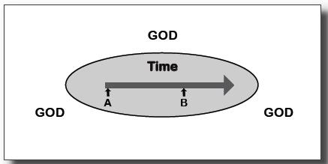

C.S. Lewis wrote in Mere Christianity, “If you picture Time as a straight line along which we have to travel, then you must picture God as the whole page on which the line is drawn. We come to the parts of the line one by one: we have to leave A behind before we get to B ,and cannot reach C until we leave B behind. God, from above or outside or all round, contains the whole line, and sees it all.” Chapter 3, “Time and Beyond Time.”
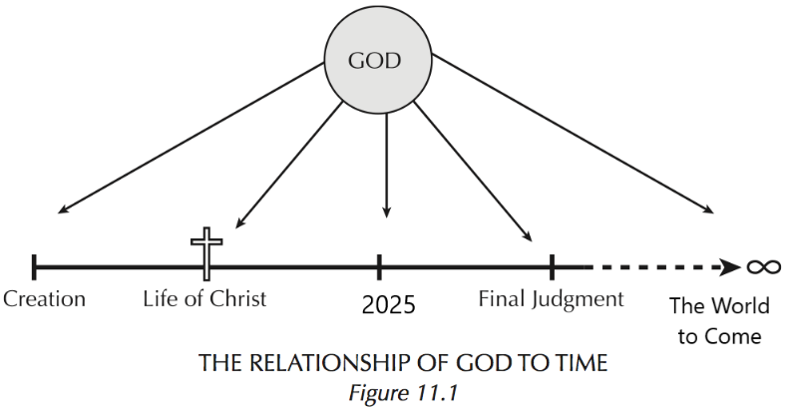
God’s view of Time
God exists outside of time, but…
- God also interacts with time
- Every moment of created time exists simultaneously for God.
Read this additional passage from C.S. Lewis, “A man put it to me by saying, ‘I can believe in God…but what I cannot swallow is the idea of him attending to several million human beings who are all addressing Him at the same moment’…what is really at the back of this difficulty is the idea of God having to fit too many things into one moment of time.”
Almost certainly God is not in Time. His life does not consist of moments following one another. If a million people are praying to Him at ten-thirty tonight, He need not listen to them all in that one little snippet which we call ten-thirty. Ten-thirty…is always the Present for Him.”
Asks students to write their interpretation.
[A theological question: can we call God “omnitemporal” as well as eternal? Do those two concepts conflict? This diagram includes “the world to come.” It is unclear whether there will be time and space in the new heaven and new earth. We profess the resurrection of the body (the return of material reality for human beings), but the exact nature of the end times are mysterious.]
Human beings and Time
- As creatures, human beings are time and space-bound.
- We have finite lifespans (a limited amount of time on earth).
- Yet, we are also created “in the image and likeness” of an eternal God.
  - We were created for eternity.
  - In this way, humans exist between time and eternity.
These first two points were touched on in a previous slide. In Genesis 1:26, God says, “Let us make human beings in our image, after our likeness.” God made us like Him. We are a reflection of a God beyond time and space who is spirit and eternity. At the same moment, we continue to be bound by space and time. God created us for eternity (he wrote it on our hearts as we’ll see in the next slide), but also within time and space.
[“The Incarnation was the biggest shock in history … That the eternal God should have a beginning in time, that the maker of Mary’s womb should be made in Mary’s womb; that the first one became the second, the independent one became dependent as a little baby, dependent for his very earthly existence.” C.S. Lewis Miracles. Quoted in Peter Kreft, Making Sense Out of Suffering.
Can we also say (because of the Incarnation) that God exists between time and space? What an incredible paradox. Lewis captures the surprise and contradiction of the Incarnation. God become human is such a familiar concept to students (and us all). Perhaps this insight can make it fresh.

The Incarnation and Time
- When God became a human being, he entered into time and space
- The birth of Jesus re-oriented time
  - Both secular and sacred calendars are centered on Christ’s birth
  - Our weekly schedules are centered on the Resurrection

The Cross: the Crux of Time
- Through the Paschal Mystery (Christ’s passion, death, and resurrection), eternity has broken into time.
- The Cross of Christ is the focal point or the crux of history.
- Jesus is the “Lord of History.”
- Through the celebration of the Eucharist, we enter into the Paschal Mystery. We experience eternity.
- “For the Son of God became human so that we might become God.” –St. Athanasius
- Made for Eternity

The Jewish calendar begins with creation, using an attempted Biblical chronology to count the years. The Hebrew year, AM 5784, began at sunset on 15 September 2023 and will end at sunset on 2 October 2024.

To “orient” originally meant to face east towards the rising sun. It referred to the new direction that churches were built facing and that people were buried towards [we hear an echo of this in the Advent hymn, “People, Look East”]. The Incarnation reoriented our buildings and our burial practices. Christ’s coming also reshaped and redirected our measurement of time. His life was so consequential that the standard calendar for the entire world counts Jesus’ birth as “Year Zero” – the fulcrum of history. In the same way, our sacred calendars (and to a lesser extent our school calendars!) are shaped by the holy-days (holidays) of the Church, which remember and call us to enter into the events of Christ’s life.

If we think about how long the human species has existed–approximately 250,000 years–it seems odd to call Christ’s life “the center of history.” And this is only human history. Think about the geological time scale! And yet, the Incarnation should be seen as a moment when eternity burst into our world. All of time was preparation for that moment. All of history was crowned by God becoming human … and still further by the events of Holy Week (which we call the Paschal Mystery). Everything that has come after in history points backwards to Christ. Jesus revolutionized not just our history but what it means to be a human being. By becoming human, Jesus wrote eternity more fully into our flesh and bones and blood. He redeemed time and space and wrote us into eternity. This is one way of understanding Athanasius’ famous (but difficult) quote.

Finally, we get a foretaste of eternity when we receive the sacraments, particularly the Eucharist. The mass is “timeless” in the sense that we are connecting directly with God. This is an experience where “time stops” and we are brought to the foot of the cross, to the Last Supper, and to the Empty Tomb.

My sheep hear my voice; I know them, and they follow me.
I give them eternal life, and they shall never perish.
No one can take them out of my hand.
John 10:27-28

My God, I am yours for time and eternity. Lord, I am yours forever. --Catherine McAuley

