Between Time and Eternity: The Catholic Understanding of Time
Guided Notes
Opening Prayer – the Suscipe of Catherine McAuley
- My God, I am yours for time and eternity.
Teach me to cast myself entirely
into the arms of your loving Providence
with a lively, unlimited confidence in your compassionate, tender pity.
Grant, O most merciful Redeemer,
- That whatever you ordain or permit may be acceptable to me.
Take from my heart all painful anxiety;
let nothing sadden me but sin,
nothing delight me but the hope of coming to the possession of You
my God and my all, in your everlasting kingdom.
Amen.
Reflection question: What is time?
Take 3 minutes and write a response to these questions in your guided notes:
- What is time? How would you explain it to a child?

Let’s discuss your responses.
St. Augustine of Hippo
- “What then is time? Provided that no one asks me, I know. If I want to explain it to an inquirer, I do not know” (St Augustine, Confessions, p. 242 2008).
- What do you make of Augustine answer?

Definition of Time (three attempts)
- Aristotle: time is a
- Thomas Aquinas: time is the measure
- Physics: Time is
What commonalities do you notice in these definitions? What repeated words? What questions do they have about these definitions?

Catholic Understanding of Time
- Time is [write all the points below]

- Time is also

- Time is ____________ by God

Two marks of creation

God’s existence
- God exists ___________ of time and space; in eternity
- Eternity is not the same as ______________.
- You [God] made all time; you are before all time; and the 'time', if such we may call it, when there was no time was not time at all" (Augustine 263).
What does this quote mean to you? Is it confusing?

Psalm 90:1-5
Lord, you have been our refuge
through all generations.
Before the mountains were born,
the earth and the world brought forth,
from eternity to eternity you are God.
You turn humanity back into dust,
saying, “Return, you children of Adam!”
A thousand years in your eyes
are merely a day gone by,
Before a watch passes in the night,
you wash them away;

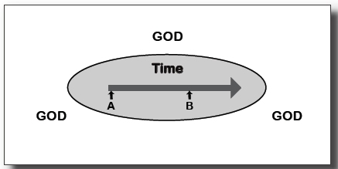

C.S. Lewis wrote in Mere Christianity, “If you picture Time as a straight line along which we have to travel, then you must picture God as the whole page on which the line is drawn. We come to the parts of the line one by one: we have to leave A behind before we get to B ,and cannot reach C until we leave B behind. God, from above or outside or all round, contains the whole line, and sees it all.” Chapter 3, “Time and Beyond Time.”

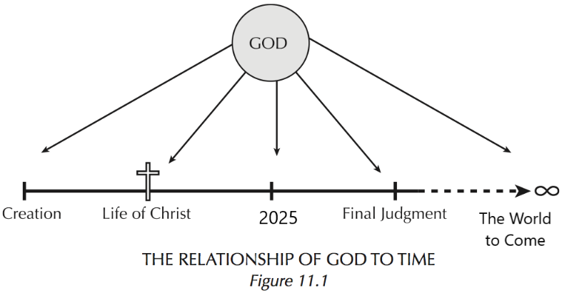

- God exists _________________ of time, but…
- God also ________________ with time
- Every moment of created time exists ________________ for God.
Listen to another passage from C.S. Lewis. How can God hear millions of people praying at once?

Human beings and time
- As creatures, human beings are time and space-____________.
- We have __________ lifespans (a limited amount of time on earth).
- Yet, we are also created _____________________________________________
  - We were created for eternity.
  - In this way, humans exist ____________ time and eternity.
The Incarnation and Time
- When God became a human being, he entered into time and space
- The birth of Jesus re-oriented time
  - Both secular and sacred calendars are centered on Christ’s birth
  - Our weekly schedules are centered on the Resurrection
“The Incarnation was the biggest shock in history … That the eternal God should have a beginning in time, that the maker of Mary’s womb should be made in Mary’s womb; that the first one became the second, the independent one became dependent as a little baby, dependent for his very earthly existence.” C.S. Lewis Miracles. Quoted in Peter Kreft, Making Sense Out of Suffering.
The Cross: the Crux of Time
- Through the Paschal Mystery (Christ’s passion, death, and resurrection), eternity has ____________________
- The Cross of Christ is the _____________________ or the ___________ of history.
- Jesus is the “____________________________.”
- Through the celebration of the Eucharist, we __________________ the Paschal Mystery. We ______________________________________.
- “For the Son of God became human so that we might become God.” –St. Athanasius
What might this quote from St. Athanasius mean for our understanding of eternity?

My sheep hear my voice; I know them, and they follow me.
I give them eternal life, and they shall never perish.
No one can take them out of my hand.
John 10:27-28
- “My God, I am yours for time and eternity. Lord, I am yours forever.” Catherine McAuley’s prayer, the Suscipe.

